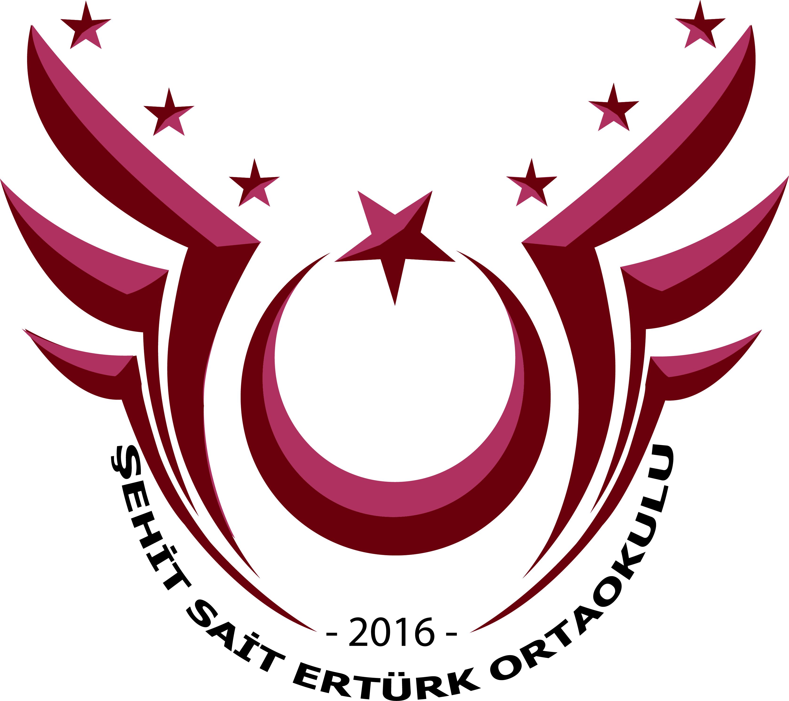
Şehit Sait Ertürk Ortaokulu
Esenler, İstanbul, Türkiye
Tel +902126112626 Mail :saiterturkortaokulu@hotmail.com;
Our School, Our Playground “, KA2, Erasmus+ Project,
№ 2017-1-EL01-KA219-036230
Minutes for the 3rd Meeting in Istanbul
23rd of October 2018, Tuesday
The teachers from Greece, Spain, Italy, Romania, Bulgaria, Cyprus and Poland arrived at our school and they were welcomed at our headmaster’s room. Our headmaster gave a speech expressing our feelings that how happy we were to welcome all partners at our school. After they tried traditional Turkish coffee and delight, they were invited to our concert hall. Our students first performed our National Anthem with sign language. After, our guests listened to chorus and guitar performance prepared by our Music teacher, Mr. Öztürk. After the coffee break, the presentation of the partner countries started. The presentations included the explanations of games which were prepared and applied by teachers from partner countries. Videos and some photos from the activities were also shown and further explanation was delivered when needed. In the evening, all the participants attended welcome diner together with Turkish delegates.

24th of October 2018, Wednesday
The teachers visited an English lesson taught by Ms. Yılmaz. As the classrooms were crowded in our school, they asked some questions about application and educational system in Turkey. Also, the students asked some questions to our guests. Ms. Yılmaz presented a demo-class using the smart board and showing the smart board apps used in the classroom. After the visit and coffee break, the new games and suggestions for the 2nd year were discussed. Our project coordinator Maria focused on digital games for the 2nd year. For digital games, some apps and sites such as Quizzlet, Learning Apps, Kahoot, Flickers, Fliptity were suggested. After the lunch which included home-made and hand-made traditional Turkish food, the partners planned the next meeting which will be held in Romania. The coordinator mentioned the topics that will be discussed in Romania. Also, the partners decided to use E-twinning more actively in order to make the students communicate. Using the blog and website of the project more frequently and uploading necessary work on the blog and website were decided by all partners. After that, the certificates, attendance sheet and all necessary documents were distributed to all partners.

25th of October 2018, Thursday
In the morning, all the partners met in front of the hotel and they visited the Topkapı Palace and Hagia Sophia. After the lunch, they had a Bosporus tour. In the evening, a farewell dinner was organized to say goodbye to all partners.

